CHURN ANALYSIS REPORT - POWER BI
Project Overview:
Customer churn remains one of the most critical challenges for subscription-based businesses, especially in competitive service industries. Every customer lost not only reduces current revenue but also increases future acquisition costs. The purpose of this analytical solution is to empower decision-makers with clear visibility into why customers leave, who is at risk, and how retention efforts can be prioritized effectively.
This Power BI solution translates business questions into meaningful visual insights distributed across two pages:
Churn Analysis – Summary
Churn Analysis – Predictions

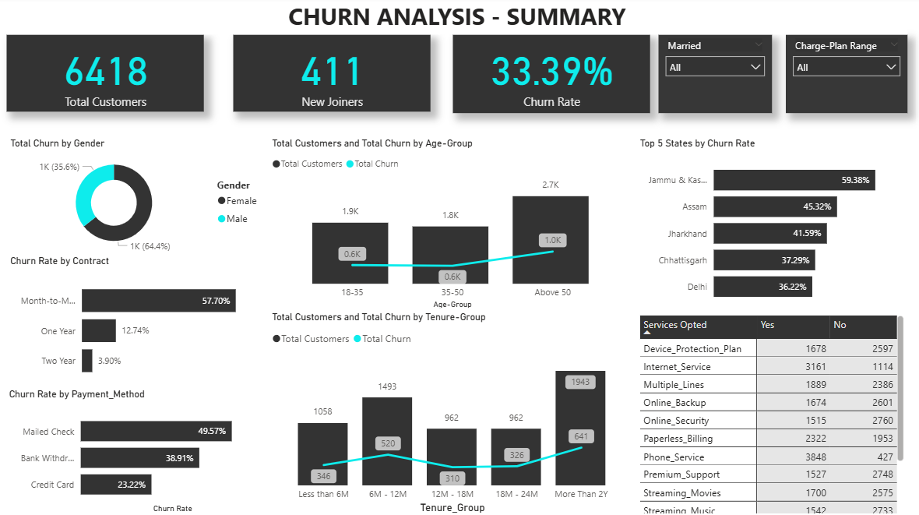

The summary page provides a comprehensive overview of customer health and churn patterns. It helps business stakeholders understand what is happening and where losses are occurring.
Key Highlights
- Total Customers and Churn Rate provide an snapshot of overall customer base health.
- New Joiners indicates the pace of customer acquisition.
Churn Breakdown Insights
Analytical View | Business Understanding
Gender | Identifies whether churn behavior is skewed by male or female customer groups
Age Group | Helps design targeted retention communication based on customer life-stage
Contract Type | Reveals if short-term commitments correlate with churn risk
Payment Method | Indicates whether certain modes (e.g., credit card, mailed check) contribute to drop-offs
Tenure Group | Shows whether early-cycle customers are more vulnerable than long-term ones
Geography (Top States) | Highlights regions requiring additional support or service improvements
Services Opted | Correlates service combinations with churn trends to identify pain points

Together, these views enable the business to diagnose churn drivers and prioritize corrective actions with evidence rather than assumptions.

CHURN ANALYSIS: PREDICTION VIEW

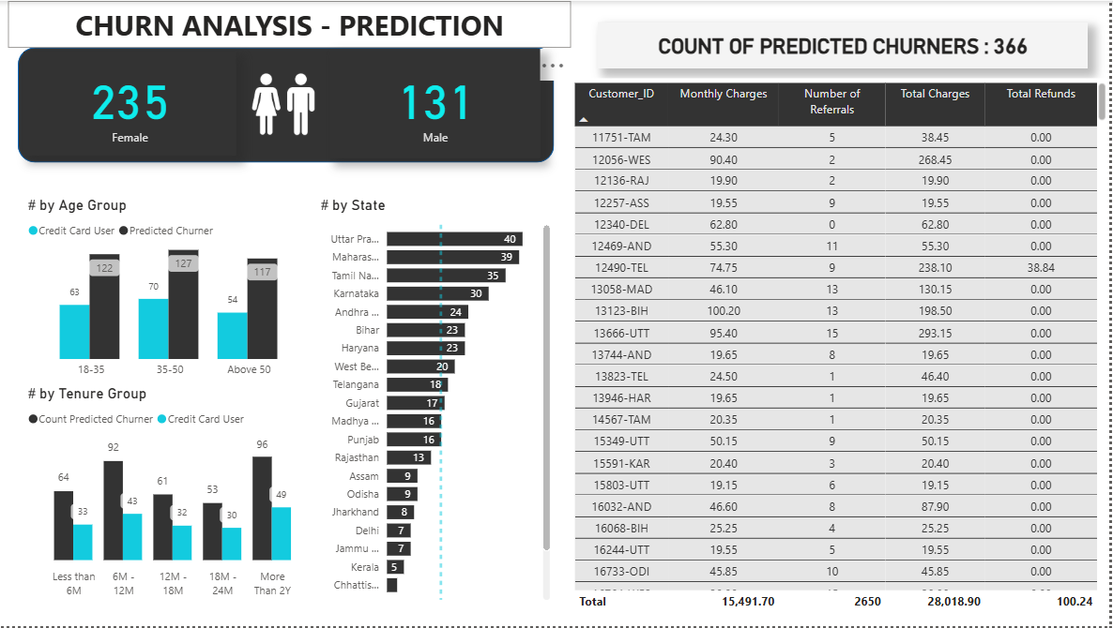

This page extends the analysis by focusing on customers who are most likely to churn, helping the business shift from a reactive approach to a proactive one.
Key Highlights
- Churn-Risk Count by Gender supports gender-based retention messaging.
- Age-Group Risk Distribution allows workforce allocation on the most vulnerable life segments.
- Tenure-Based Risk Breakdown identifies whether onboarding or long-term engagement needs attention.
- Churn-Risk by State directs regional managers to markets where intervention will yield maximum return.
- Customer-Level Table lists individual high-risk customers with details such as charges, refunds, referrals, etc., enabling direct action through CRM/Call Center Teams.

How the Business Can Use the Insights
Business Team | Functional Benefit
Retention & Customer Success | Plan outreach campaigns for high-risk segments
Marketing | Build targeted loyalty initiatives for vulnerable customer cohorts
Operations | Improve service performance in regions/patterns linked to churn
Finance | Forecast potential revenue loss and justify retention budgets
Product/Service Teams | Redesign experiences or pricing models contributing to churn

Strategic Value of This Solution
This dashboard suite shifts the organization from awareness to action:
Traditional Approach | BI-Driven Approach
React after customers leave | Intervene before churn occurs
Broad generic retention offers | Segment-wise targeted strategies
Difficult to identify root causes | Clear diagnosis of churn drivers
Limited forecasting | Forward-looking customer health monitoring

Summary
This report equips leadership with the clarity to:
- Understand why churn is happening.
- Discover which segments require urgent action.
- Prioritize retention investments intelligently.
- Safeguard recurring revenue and customer lifetime value
The insights presented across both pages ensure that churn management is data-driven, customer-focused, and proactive — ultimately building a stronger, more resilient customer base.

